# PROJECT DESIGN DOCUMENT

## Concept

The basic idea is based on a game, such as:

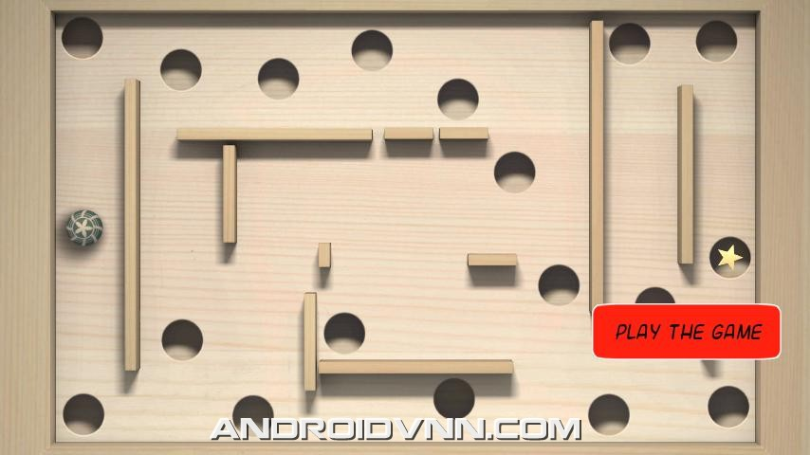  
The player will have to roll the ball into the marked holes, rolling through a maze. On the easy level, there will only be 1 ball for the player to control. On higher settings there will be more balls for the player to control. The player tilts the phone to move the balls.  
  
When one of the balls goes into the holes, it remains stationary unless the phone is tilted too much. It can roll out and come back into play. The level finishes when all of the balls are stationary in any of the holes. There will be an even number of balls and holes.  
  
The score will be dependent on the level you play on and the time it takes. You can then post this on your facebook to compete against your friends.

## Features

### Using the tilt function on a phone

The movement of the balls is controlled by tilting the phone. This affects all of the balls on the screen and has the potential to knock one that was already in a hole, back out into play again.

### Using the physics library

The physics library is something that I really want to explore and see what it offers. It has the potential to lead me on to other projects that require better use of physics for the game to work. Using the physics library in this game could affect the friction between the ball and the ground, so as the levels move on, the coefficient goes down, which makes the ball move quicker and falls out of the hole. This can be used to make the game infinite, just reuse the same levels, with the holes in a different place and the friction at a different setting.

### Different levels of difficulty

There will be 3 levels of difficulty.   
Easy – will just have 1 ball on the screen  
Medium – will have 2 balls on the screen

Hard – will have 4 balls on the screen, all being controlled by the tilt action.

The different levels will also have different coefficients of friction between the ball and the ground. As the levels get higher, the friction will get lower, making it harder to control the ball and keep them in the hole. You will also have to beat a time to get into the next round. The time will get shorter as the level gets higher.

### Multiple levels

The level design will be based around the level number. This means basically that in level one, the course will look something like,



with the hole somewhere in the middle and some gaps in the number outline to allow the ball to get in. Creating number outlines like this should allow the app to quickly scale up to 99 levels.

The holes can be places anywhere on the screen. They will be placed by a random position function.

### Holes randomly generated

The holes that the balls go into to win the game will be randomly generated each time to create a unique level each time.

### Collision detection

The balls should not go through the walls or out the sides. The balls should also hit off each other and not pass through each other. On the higher levels, hitting the ball off the wall or another ball, can spring it back or some other action.

### Score system based on level and time

The scoring system will be based on the level the player is at and the time it takes for them to complete the game. It should store the users high score and put it on a high score table. The score will use what grade you are playing at and multiply it by the time you have left to complete the level, and multiply that by what level you are on. This should then provide the option to post your score to facebook.

## “Shakey” Features

## Facebook

Create a facebook app and then use the facebook API to allow users to directly post their scores to their walls.  
  
Infinite levels

Set up levels with the level number providing the maze. This then allows new levels to be created by mixing the numbers together, so it would be possible to create an infinite number of levels quickly and easily.

## Scenes

The basic scenes will be a splash page, a menu page, a high score page, a pick your level page, a how to play the game screen and then all of the game screens.

If everything works as I hope, then I can have infinite game screens, if not, then I will create 10 or so levels for the app.   
There is no story line, it is just a simple game to play when you are bored.

## Interaction

The user interacts as you would expect. A simple touch screen layout for the menu screens and tilt screen for the game itself. If everything is implemented then you can post your high scores to facebook.